1d. Dependency Diagram for INF

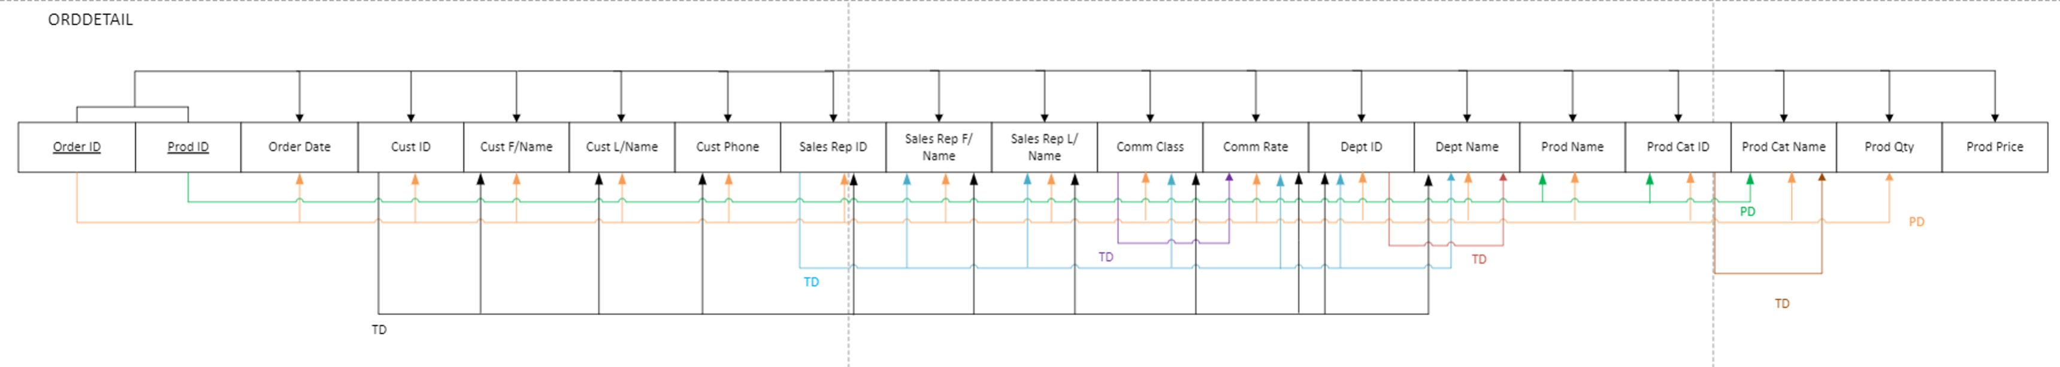2b. Dependency Diagram

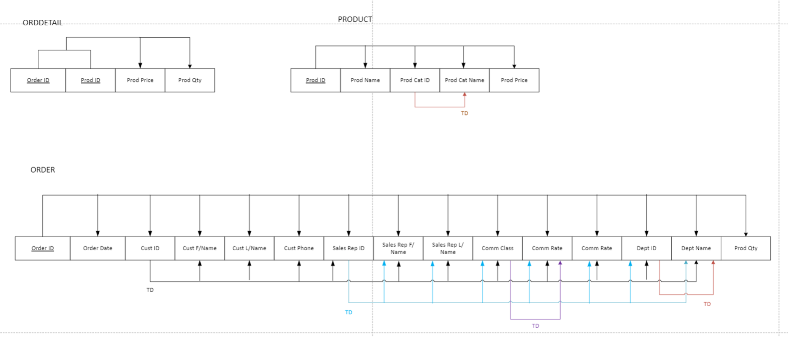

3b. Dependency Diagrams for 3NF

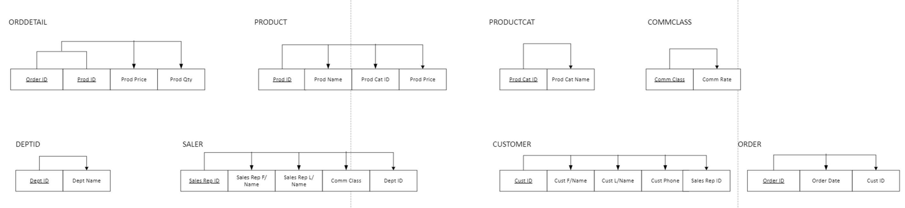

4A. Relational Schema

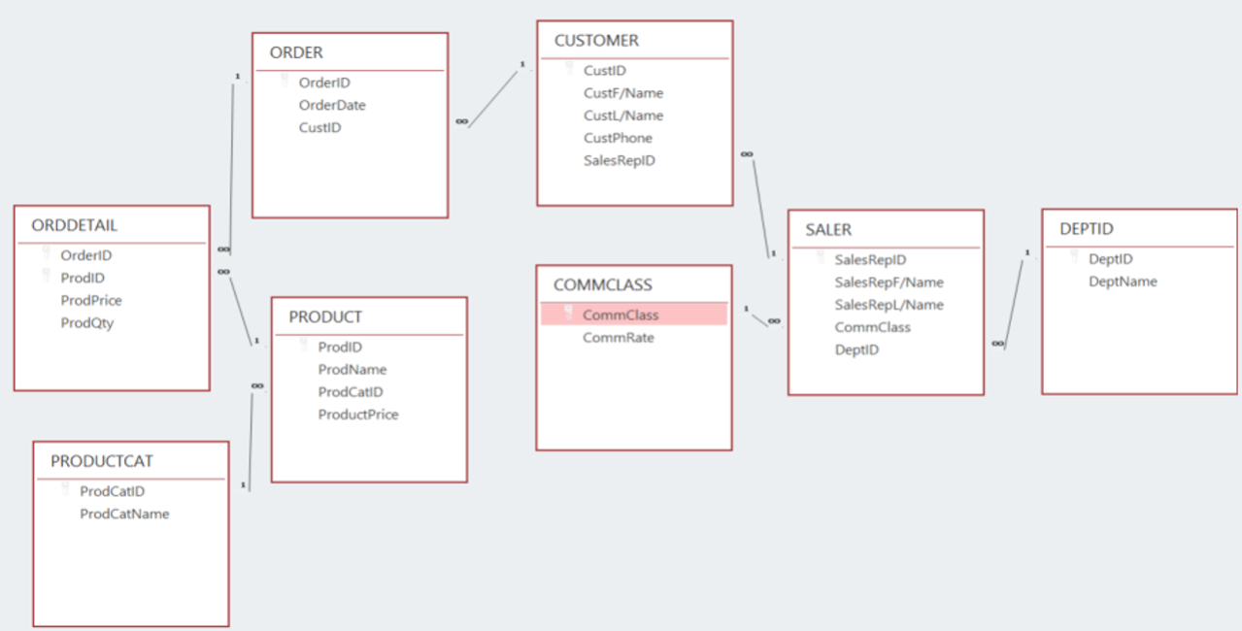

4B. CHEN NOTATION (ERD)

